PROJECT OVERVIEW DOCUMENTATION
MANA MEALS
ONLINE FOOD DELIVERY FRONTEND
APPLICATION

Prepared By: Internship Trainee
Internship Domain: Frontend Development
Project Type: E-Commerce / Food Delivery Frontend Application
Technologies: HTML, CSS, JavaScript, React.js, Tailwind CSS

INDEX

- Introduction
- Project Name
- Project Objective
- Project Description
- Problem Statement
- Target Users
- Features List
- Functional Requirements
- Non-Functional Requirements
- User Requirements
- System Requirements
- User Interface Design
- Frontend Workflow
- Technologies Used
- Folder Structure
- Future Enhancements
- Expected Outcome
- Conclusion

1. Introduction
The food delivery industry has experienced rapid growth due to increasing internet usage and digital convenience. Customers prefer online food ordering systems because they save time and provide easy access to restaurants and food services. Modern food delivery applications such as Swiggy and Zomato have transformed the way customers order food.
Mana Meals is developed as a frontend-based online food delivery application that provides users with a smooth and attractive food ordering experience. The project focuses on modern UI/UX design, responsive layouts, reusable frontend components, and interactive user interfaces using React.js and frontend technologies.
This project helps in understanding real-world frontend development workflows and professional project structuring standards used in the software industry.
2. Project Name
Mana Meals – Online Food Delivery Frontend Application
The name “Mana Meals” represents a modern and user-friendly food delivery platform designed to deliver meals quickly and efficiently. The branding focuses on simplicity, convenience, and attractive user experience.
3. Project Objective
The main objective of the project is to develop a modern and responsive food delivery frontend application using React.js and frontend development technologies.
The project objectives include:
- Understanding frontend development concepts
- Learning responsive web design principles
- Creating reusable React components
- Designing professional UI/UX interfaces
- Implementing smooth navigation systems
- Building interactive user interfaces
- Understanding project planning and documentation
- Improving frontend development skills
The project also helps in gaining practical industry-level development experience.
4. Project Description
Mana Meals is a frontend-based e-commerce food delivery web application that allows users to browse restaurants, search food items, explore categories, and place food orders through a modern digital interface.
The application includes:
- Homepage with hero section
- Restaurant listing section
- Search functionality
- Food category filtering
- Promotional banners
- Cart interface
- Login and signup pages
- Responsive navigation system
- Food cards with pricing
- User-friendly design
The application is designed using React.js and modern CSS frameworks to provide a smooth and responsive user experience across different devices.
5. Problem Statement
Many local restaurants and small food businesses do not have proper online food ordering platforms. Existing problems include:
- Poor user interface design
- Non-responsive websites
- Slow ordering process
- Difficult navigation systems
- Lack of digital accessibility
- Poor customer experience
Mana Meals aims to solve these problems by developing a responsive and user-friendly frontend food delivery application that improves online ordering convenience and customer interaction.
6. Target Users
The application is mainly designed for the following users:
General Customers
Users who want fast and convenient online food ordering services.
Students
Students who regularly order affordable meals online.
Working Professionals
Office employees and professionals who need quick food delivery during working hours.
Restaurant Owners
Restaurants that want to increase online visibility and digital orders.
Local Food Businesses
Small food businesses looking for affordable online food ordering platforms.
7. Features List
User Features
- Responsive homepage
- Restaurant listing section
- Food category filtering
- Search functionality
- Add to cart system
- Login and signup pages
- Food menu display
- Order button functionality
- Mobile-friendly design
- Promotional offers section

UI Features
- Modern UI design
- Smooth animations
- Hover effects
- Interactive buttons
- Responsive layouts
- Professional colour palette
- Attractive typography

Additional Features
- Wishlist functionality
- Customer reviews section
- Ratings display
- Dark mode support
- Live order tracking UI
- Notification section
8. FUNCTIONAL REQUIREMENTS
Functional requirements explain what the Mana Meals application should do and how users interact with the website in real-life situations.
User Functional Requirements
1. User can browse restaurants and food items
When users open the Mana Meals website, they should be able to explore different restaurants and food items easily.
For example, a user opens the homepage and sees restaurant cards with images, ratings, and food categories. By clicking on a restaurant, the user can view the available menu items and prices.
This feature helps users quickly discover meals they want to order.
2. User can search food items using the search bar
Users should be able to search for their favorite food items without scrolling through the entire website.
For example, if a user types “Burger” in the search bar, the website should instantly show burger-related food items and restaurants.
This makes food searching faster and improves user convenience.
3. User can filter food items by categories
The application should allow users to filter foods based on categories such as:
- Veg
- Non-Veg
- Fast Food
- Desserts
- Beverages
For example, if a user clicks on the “Desserts” category, only dessert items should appear on the screen.
This helps users find food more easily.
4. User can view restaurant details and menus
Users should be able to view complete restaurant information before ordering food.
When a user clicks on a restaurant, the application should display:
- Restaurant name
- Ratings
- Delivery time
- Food menu
- Prices
- Food images
This helps users make better ordering decisions.
5. User can add products to cart
The website should allow users to add food items to their cart before placing the order.
For example, when a user clicks the “Add to Cart” button, the selected item should be stored in the shopping cart.
The cart should also show:
- Food item name
- Quantity
- Total price
This feature helps users manage their order easily.
6. User can remove products from cart
Users should also be able to remove unwanted food items from the cart.
For example, if a user changes their mind about ordering pizza, they can click the “Remove” button to delete it from the cart.
The total amount should automatically update after removal.
7. User can update food item quantities in the cart
Users should be able to increase or decrease food quantity depending on their needs.
For example:
- Clicking “+” increases quantity.
- Clicking “−” decreases quantity.
The price should update automatically based on quantity changes.
8. User can proceed to checkout
After selecting food items, users should be able to continue to the checkout page.
The checkout page should display:
- Selected items
- Quantity
- Delivery details
- Total amount
This helps users confirm their order before placing it.
9. User can create an account using signup functionality
New users should be able to register on the website.
The signup form may ask for:
- Name
- Email
- Password
- Phone number
After successful registration, users can log in and use personalized features.
10. User can log in using registered credentials
Existing users should be able to log in securely using their email and password.
After login:
- User profile becomes accessible.
- Cart and Wishlist data can be stored.
This provides a personalized user experience.
11. User can view promotional offers and discounts
The homepage should display special offers and discount banners.
For example:
- “50% OFF on First Order”
- “Free Delivery Today”
These promotional offers attract users and improve engagement.
12. User can add items to Wishlist
Users should be able to save favourite food items for future ordering.
For example, clicking the heart icon saves the food item in the wishlist section.
This improves user convenience and engagement.
13. User can view customer reviews and ratings
Before ordering, users should be able to check customer feedback.
The application should display:
- Star ratings
- Customer comments
- Food reviews
This helps users trust the restaurant and food quality.
14. User can track orders through tracking UI
After placing an order, users should be able to track delivery progress.
Order status examples:
- Order Confirmed
- Preparing Food
- Out for Delivery
- Delivered
This keeps users informed about their orders.
15. User can access the website from desktop and mobile devices
The Mana Meals website should work smoothly on:
- Mobile phones
- Tablets
9. NON-FUNCTIONAL REQUIREMENTS
Non-functional requirements explain how well the Mana Meals application should perform. These requirements focus on the quality, speed, security, usability, and overall user experience of the website rather than specific features.
1. Performance Requirements
The Mana Meals website should load quickly and work smoothly without delays.
When users open the website, pages should appear within a few seconds so that users do not feel frustrated or leave the application. Searching for food items, opening restaurant pages, and adding items to the cart should happen quickly and smoothly.
For example, when a user searches for “Pizza,” the results should appear instantly without long waiting times.
Good performance improves customer satisfaction and creates a better user experience.
2. Usability Requirements
The application should be simple, user-friendly, and easy to understand for all users.
Even first-time users should be able to navigate the website without confusion. Buttons, menus, and icons should be clearly visible and properly organized.
For example:
- Users should easily identify the “Add to Cart” button.
- Navigation menus should be simple to use.
- Food categories should be clearly displayed.
A clean and simple interface helps users order food comfortably and quickly.
3. Responsive Design Requirements
The Mana Meals website should work properly on all devices such as:
- Mobile phones
- Tablets
- Laptops
- Desktop computers
The layout should automatically adjust according to screen size so that users get a smooth experience on every device.
For example:
- On mobile phones, menus should fit smaller screens properly.
- Images and buttons should resize automatically.
- Text should remain readable on all devices.
This improves accessibility and allows users to order food anytime from any device.
4. Reliability Requirements
The application should work consistently without crashes or errors.
Users should be able to:
- Browse restaurants
- Add items to the cart
- Navigate pages
- Complete orders
without facing technical issues.
For example, the cart should not suddenly become empty or stop working while users are placing orders.
Reliable systems improve customer trust and satisfaction.
5. Security Requirements
The application should protect user information and provide a safe environment for users.
Sensitive data such as:
- Email addresses
- Passwords
- Personal details
should be secured properly.
The system should also validate forms to prevent invalid data entry.
For example:
- Password fields should remain hidden.
- Invalid email formats should show warnings.
- Unauthorized users should not access admin features.
Security helps protect user privacy and builds trust in the application.
6. Maintainability Requirements
The project code should be organized, clean, and easy to maintain.
Developers should be able to:
- Update features
- Fix bugs
- Add new components
without affecting the entire application.
For example:
- React components should be reusable.
- Folder structures should be properly organized.
- CSS files should be easy to manage.
Good maintainability helps future development become faster and easier.
7. Scalability Requirements
The application should support future growth and additional features.
As the number of users and restaurants increases, the website should still perform efficiently.
For example, in the future the application may include:
- Online payment systems
- Live order tracking
- AI-based food recommendations
- Multi-language support
The system architecture should be flexible enough to support these future enhancements.
Scalability ensures that the project can grow into a complete full-stack food delivery platform in the future.
10. USER REQUIREMENTS
Customer Requirements
Customers expect the Mana Meals application to make food ordering fast, simple, and convenient. They want an attractive and easy-to-use website where they can quickly search restaurants, add food items to the cart, and place orders without confusion. Users also expect smooth checkout, secure login functionality, mobile-friendly access, and real-time order tracking for a better experience.
Restaurant Owner Requirements
Restaurant owners expect the platform to help improve their online presence and attract more customers. They want an easy way to manage food menus, update prices, display offers, and interact with customers through reviews and ratings.
Student & Professional Requirements
Students expect affordable food options and discount offers that fit their budget. Working professionals want quick and hassle-free food ordering during busy working hours, helping them save time and order meals easily.
11. SYSTEM REQUIREMENTS
1. System should display food items dynamically
The application should automatically display food items using stored data and React components.
2. System should support smooth navigation between pages
Users should move smoothly between pages such as:
- Home
- Cart
- Login
- Restaurant details
without page refresh delays.
3. System should maintain cart data during user session
The cart should not reset immediately when users navigate to other pages.
This improves user convenience during ordering.
4. System should validate login and signup forms
The system should check user input properly.
For example:
- Email format validation
- Password length checking
- Empty field warnings
This improves security and data accuracy.
5. System should display responsive layouts across devices
The website design should automatically adjust for all screen sizes.
This ensures a smooth user experience on every device.
6. System should provide interactive UI components and animations
The application should include:
- Hover effects
- Smooth animations
- Interactive buttons
- Loading transitions
12. User Interface Design
The UI design of Mana Meals focuses on creating a clean, modern, and attractive food delivery interface.
The interface includes:
- Professional homepage layout
- Modern navigation bar
- Search bar with icons
- Food categories section
- Restaurant cards
- Promotional banners
- Responsive mobile layouts
- Smooth scrolling sections
The design uses attractive colour combinations such as orange, green, white, and light backgrounds to create a professional food delivery theme.
The overall UI design improves accessibility, readability, and user engagement.
13. Frontend Workflow
The frontend workflow follows a structured food ordering process.
Workflow Steps
Step 1
User opens the homepage.
Step 2
User browses restaurants or searches food items.
Step 3
User selects preferred food items.
Step 4
Selected items are added to the cart.
Step 5
User proceeds to checkout.
Step 6
Order confirmation screen is displayed.
The workflow is designed to reduce user effort and improve navigation efficiency.
14. Technologies Used
Technology | Purpose
HTML | Structure of web pages
CSS | Styling and layouts
JavaScript | Dynamic functionalities
React.js | Frontend development
Tailwind CSS | Modern styling
Bootstrap | Responsive layouts
GitHub | Version control
React Router | Navigation and routing
Font Awesome | Icons and UI elements
VS Code | Code editor

15. Folder Structure
src/
├── components/
├── pages/
├── assets/
├── layouts/
├── styles/
├── services/
├── routes/
├── App.js
└── index.js
Folder Description
Folder | Purpose
components | Reusable UI components
pages | Website pages
assets | Images and icons
layouts | Layout structures
styles | CSS files
services | API and utility functions
routes | Navigation routing

16. Future Enhancements
The future enhancements planned for the project include:
- Backend integration
- Payment gateway integration
- Firebase authentication
- Real-time order tracking
- Admin dashboard
- Restaurant management panel
- AI-based food recommendations
- Push notification system
- Multi-language support
- Customer chat support
These features will help transform the project into a complete full-stack food delivery platform.
17. Expected Outcome
After completing the project, the application will provide:
- A professional food delivery frontend interface
- Responsive design for all devices
- Smooth user experience
- Interactive food ordering system
- Modern UI/UX design
- Practical frontend development experience
The project will also improve knowledge of React.js and frontend workflows.

MANA MEALS

Document Type: UI/UX Production Specification & Wireframe Blueprint
Frontend Domain: React.js, Tailwind CSS, JavaScript E-Commerce Framework
Prepared By: Frontend Engineering & Design Trainee Team
Target Audience: General Customers, Students, Working Professionals, Restaurant Owners

1. Executive Summary & Design System Rationale
The rapid growth of digital food delivery architectures has highlighted critical layout deficiencies among local restaurant interfaces, which often exhibit non-responsive frameworks, challenging search hierarchies, and slow ordering sequences.
Mana Meals acts as a production-grade front-end solution engineered specifically to establish optimal digital layouts, high accessibility, and high-performance cross-device performance.
This blueprint bridges structural documentation with visual layouts. By translating low-fidelity wireframe interfaces into accurate, coloured Tailwind CSS specifications, this system ensures clean components, lightning-fast rendering states, and an appetizing presentation optimized for user conversion.
2. Complete Colour System Mapping
Colours are configured natively through functional design tokens inside Tailwind CSS to facilitate instant dark-mode toggles, interactive animations, and colour-accurate accessibility compliance.

Brand Primary Orange
#FF5A00 (Tailwind orange-600 alternative)
The central interactive token. Applied to high-impact call-to-actions, primary active validation states, navigation logo branding, and checkout highlights. Encourages conversion.
Deep Charcoal Blue
#1F2937 (Tailwind gray-800)
Enforces baseline contrast requirements. Applied across navigation backdrops, critical alphanumeric text hierarchies, form inputs, and strong page section headers.
Success & Veg Green
#10B981 (Tailwind emerald-500)
Represents organic/Veg filtering criteria, positive restaurant score badges (e.g., 4.5+ Stars), complete transaction alerts, and promotional text indicators.

Promo / Discount Crimson
#EF4444 (Tailwind red-500)
Highlights critical limited-time flash discounts, non-veg indicators, live shipping route maps, active delivery vehicle pins, and empty state cart warnings.

3. Typographic Scale Configuration
Using geometric sans-serif typefaces (e.g., Inter or Poppins), the interface maximizes readability during high-velocity mobile interaction states.
Typography Level | Font Size | Font Weight | Tailwind Class | Usage
Hero Display | 36px | Bold (700) | text-4xl font-bold | Homepage main promotional tagline
Section Header (H1) | 24px | Semi Bold (600) | text-2xl font-semibold | Popular Restaurants, Your Shopping Cart
Card Subhead (H2) | 18px | Semi Bold (600) | text-lg font-semibold | Food Item Titles, Restaurant Card Names
Body Running Text | 16px | Regular (400) | text-based font-normal | Cuisine summaries and detailed addresses
Metadata Badges | 14px | Medium (500) | text-sm font-medium | Delivery ETAs, pricing metrics, timestamps

4. Wireframe Layout Mapping & UI Colour Infusion
The following architectural schematics align standard component layouts directly with the structural wireframes, illustrating how components display colour changes across various screen flows.
Homepage & Restaurant Directory Layout
Layout Strategy:
Features a sticky global desktop navbar with immediate input search anchors. The system infuses promotional banners with secondary colours to catch the eye instantly without layout shifting.
MANA MEALS | Search Food Items | Cart [0] | Login
50% OFF ON FIRST ORDER
Order from top rated local cuisines instantly
Filter Categories:
- Veg Only
- Non-Veg
- Desserts
Popular Restaurants:

Pizza Hub
The Pizza Palace
4.6 (Success Green)
Italian • 25 mins
Free Delivery
Burger King
Burger Station
4.2 (Success Green)
Fast Food • 15 mins
30% OFF Up to ₹75
Sweet Treat
Delight Bakery
4.8 (Success Green)
Desserts • 30 mins
Top Rated

Restaurant Menu Detail View
Layout Strategy:
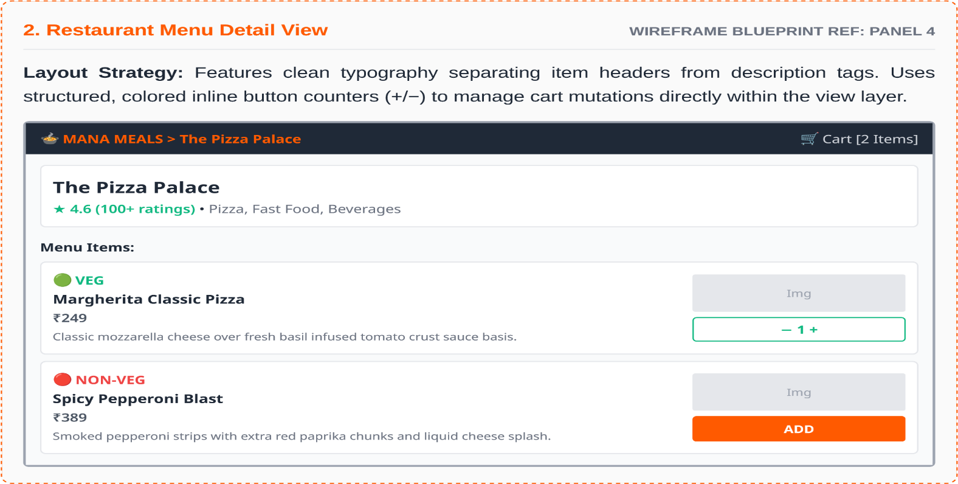
Features clean typography separating item headers from description tags. Uses structured, coloured inline button counters (+/−) to manage cart mutations directly within the view layer.

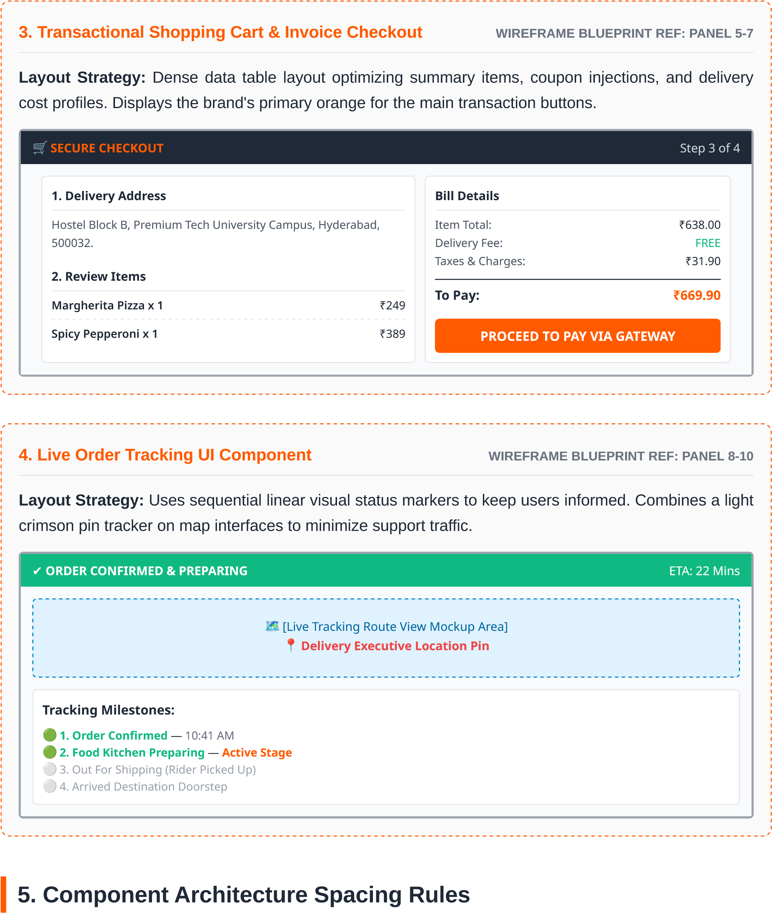
5. Component Architecture Spacing Rules
To preserve UI responsiveness, layout structures follow explicit mathematical spacing constraints enforced uniformly through global CSS wrappers.
Outer Layout Margins:
Liquid horizontal gutters structured via padding: 0 16px (px-4) across mobile portrait viewports, scaling to fixed boundaries of max-width: 1280px with auto cantering on desktop configurations.
Structural Grid Gaps:
Category lists and primary food display card containers use standard grid configurations of gap: 24px (gap-6) to prevent accidental multi-element link triggers.
Component Padding Box Models:
Standard content view blocks use uniform box-inset variables of padding: 16px (p-4), isolating graphics from primary textual information hierarchies.
Financial totals and checkout blocks use dense padding: 24px (p-6) to make payment options and details easy to read.
6. Interactive Button Layout Profiles
Primary Interactive CTA:
Solid primary orange background accompanied by bold white texts, featuring border-radius: 8px. Changes colour to deeper hues upon interaction to confirm user selections.
Secondary / Action Inline:
Outlined boundaries featuring explicitly clear green text structures paired with light, desaturated white hover shifts. Simplifies adjustments directly from card structures.
Muted Utility Options:
Transparent, borderless structures using light grey or blue highlights to handle standard clear-all filters or settings management without drawing focus from primary checkout paths.

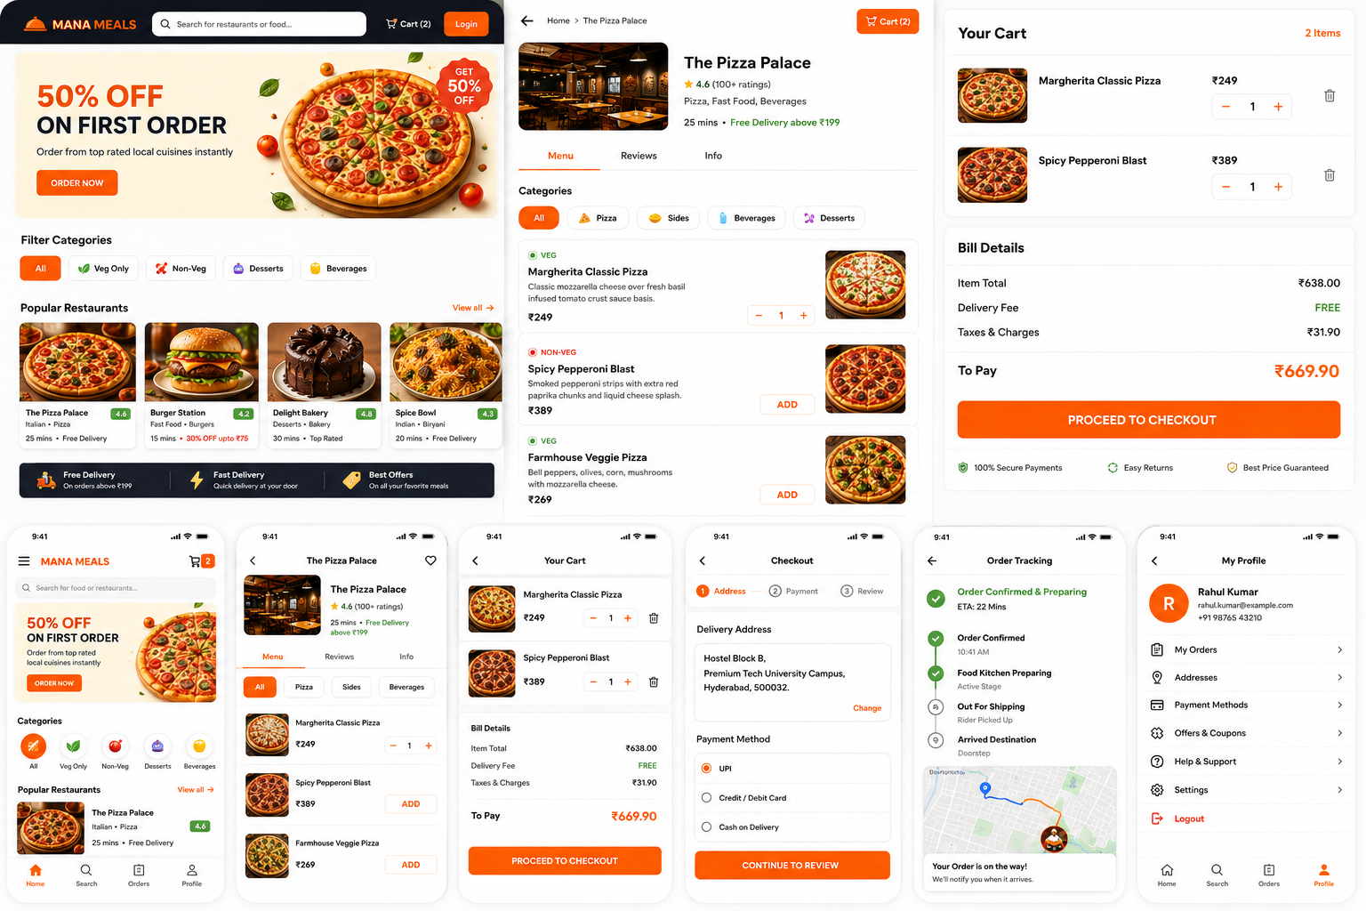

File structure
mana-meals/
│
├── public/
│ ├── images/
│ ├── icons/
│ └── logo.png
│
├── src/
│
│ ├── assets/
│ │ ├── images/
│ │ ├── icons/
│ │ └── fonts/
│
│ ├── components/
│ │
│ ├── layout/
│ │ ├── Navbar/
│ │ ├── Footer/
│ │ └── Sidebar/
│ │
│ ├── pages/
│ │ ├── Home/
│ │ ├── Restaurant/
│ │ ├── Menu/
│ │ ├── Cart/
│ │ ├── Checkout/
│ │ ├── Orders/
│ │ ├── Tracking/
│ │ ├── Profile/
│ │ ├── Login/
│ │ └── Register/
│ │
│ ├── components/
│ │ ├── Button/
│ │ ├── RestaurantCard/
│ │ ├── FoodCard/
│ │ ├── CategoryFilter/
│ │ ├── SearchBar/
│ │ ├── RatingBadge/
│ │ ├── CartItem/
│ │ ├── OrderStatus/
│ │ └── Loader/
│ │
│ ├── routes/
│ │ └── AppRoutes.jsx
│ │
│ ├── services/
│ │ ├── api.js
│ │ ├── authService.js
│ │ ├── restaurantService.js
│ │ └── orderService.js
│ │
│ ├── context/
│ │ ├── AuthContext.jsx
│ │ ├── CartContext.jsx
│ │ └── RestaurantContext.jsx
│ │
│ ├── hooks/
│ │ ├── useAuth.js
│ │ ├── useCart.js
│ │ └── useFetch.js
│ │
│ ├── utils/
│ │ ├── constants.js
│ │ ├── helpers.js
│ │ └── validation.js
│ │
│ ├── styles/
│ │ ├── index.css
│ │ ├── variables.css
│ │ └── global.css
│ │
│ ├── tests/
│ │ ├── Home.test.jsx
│ │ ├── Cart.test.jsx
│ │ └── Login.test.jsx
│ │
│ ├── App.jsx
│ ├── main.jsx
│ └── vite-env.d.ts
│
├──. ENV
├──. ENV.DEVELOPMENT
├──. ENV.PRODUCTION
├── package.json
├── vite.config.js
└── README.md

18. Conclusion
Mana Meals is designed as a professional frontend food delivery application that demonstrates modern frontend development concepts and responsive UI design principles.
The project helps in understanding industry-level frontend workflows, component-based architecture, navigation systems, and professional project planning standards.
This project acts as a strong foundation for future full-stack web application development and improves practical frontend development knowledge.

